ICE 4201 Data Structures and Algorithms
Assignment 4

COMPLETED BY: ERNEST EBOAGWU
500627328

Excercise 4.1
Benchmarking Stacks:
# Completed implementation of a stack ADT

import random
import timeit
from timeit import Timer

class Stack1:
def __init__(self):
self.items = []
def is_empty(self):
return self.items == []
def push(self, item):
self.items.append(item)
def pop(self):
return self.items.pop()
def peek(self):
return self.items[len(self.items)-1]
def size(self):
return len(self.items)

class Stack2:
def __init__(self):
self.items = []
def is_empty(self):
return self.items == []
def push(self, item):
self.items.insert(0, item)
def pop(self):
return self.items.pop(0)
def peek(self):
return self.items[0]
def size(self):
return len(self.items)

rand_num=0
def testStack1():
# Testing specific random number
# initializing the stack
s1= Stack1()

# push(item) adds a new item to the top of the stack. It needs the item and returns nothing.
s1.push(random.randint(0, rand_num))

# pop Remove the integers from the stack
s1.pop()
# is_empty tests to see whether the stack is empty.
s1.is_empty()
# size returns the number of items on the stack
s1.size()

def testStack2():
# Testing specific random number
# Testing specific random number
# initializing the stack
s2= Stack2()

# push(item) adds a new item to the top of the stack. It needs the item and returns nothing.
s2.push(random.randint(0, rand_num))

# pop Remove the integers from the stack
s2.pop()
# is_empty tests to see whether the stack is empty.
s2.is_empty()
# size returns the number of items on the stack
s2.size()

if __name__ == '__main__':
t1 = Timer("testStack1()", "from __main__ import testStack1")
print("testStack1 for 1 million int",t1.timeit(number=1000000), "milliseconds")

t2 = Timer("testStack2()", "from __main__ import testStack2")
print("testStack2 for 1 million int",t1.timeit(number=1000000), "milliseconds")

t1 = Timer("testStack1()", "from __main__ import testStack1")
print("testStack1 for 10 million int",t1.timeit(number=10000000), "milliseconds")

t2 = Timer("testStack2()", "from __main__ import testStack2")
print("testStack2 for 10 million int",t1.timeit(number=10000000), "milliseconds")

t1 = Timer("testStack1()", "from __main__ import testStack1")
print("testStack1 for 100 million int",t1.timeit(number=100000000), "milliseconds")

t2 = Timer("testStack2()", "from __main__ import testStack2")
print("testStack2 for 100 million int",t1.timeit(number=100000000), "milliseconds")

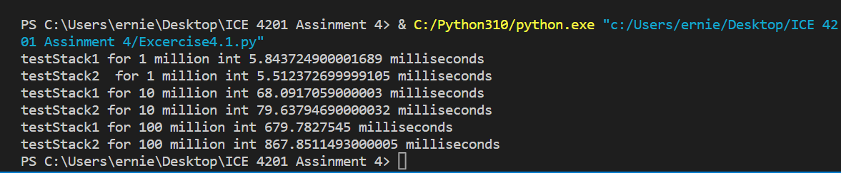

1 Million Integer 10 Million Integer 100 Million Integer
Stack 1 Timing (milliseconds) | 5.843724900001689 | 68.0917059000003 | 679.7827545
Stack 2 Timing (milliseconds) | 5.512372699999105 | 79.63794690000032 | 867.8511493000005
Table 1: Result for the two stacks
Discussion
In this exercise involves benchmarking the two stacks for different random integers of 1 million, 10 million and 100 million.
It was observed that the first stack function with append method pushes the items into the stack faster than the stack function with insert method to push item to the stack. Therefore, the first stack function is more time efficient than the second stack function.

Exercise 4.2 Using Stacks

def lisp_evaluation(item):
#replace brackets with an empty string in the expression
trimItem = item.replace("(", "")
trimItem = trimItem.replace(")", "")
items = trimItem.split(" ")
# Create stacks to hold the operands
stack1 = []
stack2 = []

# Iterate through the items
for i in reversed(items):
if i == "+":
# Remove the two operands from the stack, add them, and push the output back to the stack
operand1 = stack1.pop()
operand2 = stack1.pop()
output = operand1 + operand2
stack1.append(output)
elif i == "-":
# Remove the two operands from the stack, subtract the second operand from the first, and push the output back to the stack
operand1 = stack1.pop()
operand2 = stack1.pop()
output = operand1 - operand2
stack1.append(output)
elif i == "*":
# Remove the two operands from the stack, multiply them, and push the output back to the stack
operand1 = stack1.pop()
operand2 = stack1.pop()
output = operand1 * operand2
stack1.append(output)
elif i == "/":
# Remove the two operands from the stack, divide the first operand by the second, and push the output back to the stack
operand1 = stack1.pop()
operand2 = stack1.pop()
output = operand1 / operand2
stack1.append(output)
else:
# If the i is not an operator, it must be an operand. Convert it to a number and push it to the stack
stack1.append(int(i))
if(len(stack1) == 1):
return stack1[0]
#check the first operator
operator = i[0]
# The last output should be the only element left on the stack
for j in reversed(stack1):

if operator == "+":
# Remove the two operands from the stack, add them, and push the output back to the stack
operand1 = stack1.pop()
operand2 = stack1.pop()
output = operand1 + operand2
stack2.append(output)
elif operator == "-":
# Remove the two operands from the stack, subtract the second operand from the first, and push the result back to the stack
operand1 = stack1.pop()
operand2 = stack1.pop()
output = operand1 - operand2
stack2.append(output)
elif operator == "*":
# remove the last two operands from the stack, multiply them, and push the result back to the stack
operand1 = stack1.pop()
operand2 = stack1.pop()
output = operand1 * operand2
stack2.append(output)
elif operator == "/":
# Pop the last two operands from the stack, divide the first operand by the second, and push the result back to the stack
operand1 = stack1.pop()
operand2 = stack1.pop()
output = operand1 / operand2
stack2.append(output)
else:
# If the j is not an operator, it must be an operand. Convert it to a number and push it to the stack
stack2.append(int(j))

return stack2[0]

# Test the interpreter
print(lisp_evaluation("(+ (* 5 6) (* 4 5) (* 2 6))"))
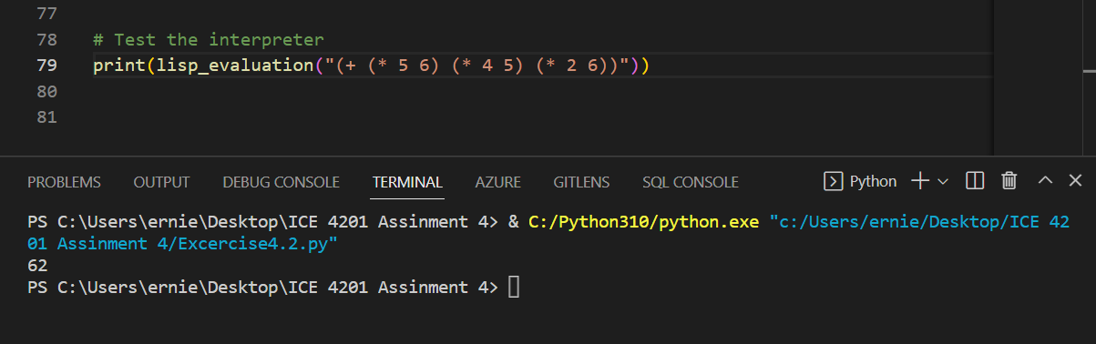

Exercise 4.3 – Benchmarking Queues
import random
import timeit
from timeit import Timer
# Completed implementation of a queue ADT
class Queue:
def __init__(self):
self.items = []
def is_empty(self):
return self.items == []
def enqueue(self, item):
self.items.insert(0,item)
def dequeue(self):
return self.items.pop()
def size(self):
return len(self.items)

def testQueue():
# Number of integers to insert and remove from the stack
num_integers = int()

#initialize the Queue
queue = Queue()
# Insert the integers onto the queue
queue.enqueue(random.randint(0, num_integers))

# Remove the integers from the queue
queue.dequeue()
return queue.is_empty()

if __name__ == '__main__':
t = Timer("testQueue()", "from __main__ import testQueue")
print("testQueue for 1 million int",t.timeit(number=1000000), "milliseconds")

t = Timer("testQueue()", "from __main__ import testQueue")
print("testQueue for 10 million int",t.timeit(number=10000000), "milliseconds")

t = Timer("testQueue()", "from __main__ import testQueue")
print("testQueue for 100 million int",t.timeit(number=100000000), "milliseconds")

Random Number | TimeIt (Milliseconds)
1 million | 5.70424539999658
10 million | 59.38683350000065
100 million | 713.6184605999988

A queue is designed to input items at one end and remove items from the other end. This is known as a First-In-First-Out (FIFO) data structure because the first element added to the queue is the first to be pulled out. A stack is designed the other way around. This is known as a Last-In-First-Out (LIFO) data structure because the last element added to the stack is the first one to be removed.
The main difference between queues and stacks is the order in which items are added or removed. In a queue, the first added item is the first to be removed, while the last added item in a stack, is the first to be removed. These qualities also influence how these algorithms are applied in problem solving.

Exercise 4.4 – Using Queues
class Queue:
def __init__(self):
self.items = []
def is_empty(self):
return self.items == []
def enqueue(self, item):
self.items.insert(0,item)
def dequeue(self):
return self.items.pop()
def size(self):
return len(self.items)

def simulate(numCars, behavior):
# initialize the queue
queue = Queue()
# compute the total wait time for all cars
total_wait_time = int()
# Iterate over the number of cars
for car in range(numCars):
# Each car has a random arrival time between 0 and 5 seconds
arrival_time = random.uniform(0, 5)
# If the behavior is 1 (change lanes), add the car to the queue and update the wait time
if behavior == 1:
queue.enqueue(arrival_time)
total_wait_time += queue.size() * arrival_time
# If the behavior is 2 (stay in lane), only add the car to the queue if it's empty
elif behavior == 2:
if queue.is_empty():
queue.enqueue(arrival_time)
else:
total_wait_time += arrival_time
# Return the average wait time for all cars
avg_waiting_time = total_wait_time/numCars
return avg_waiting_time

# Simulate behavior 1 for 1000 cars
avg_wait_time_1 = simulate(1000, 1)
print("Average wait time for behavior 1:", avg_wait_time_1,'in milliseconds')

# Simulate behavior 2 for 1000 cars
avg_wait_time_2 = simulate(1000, 2)
print("Average wait time for behavior 2:", avg_wait_time_2 ,'in milliseconds')

# To determine which behavior has a shorter average wait time
if avg_wait_time_1 < avg_wait_time_2:
print("Behavior 1 has a shorter average waiting time than behaviour 2.")
else:
print("Behavior 2 has a shorter average waiting time than behaviour 1.")

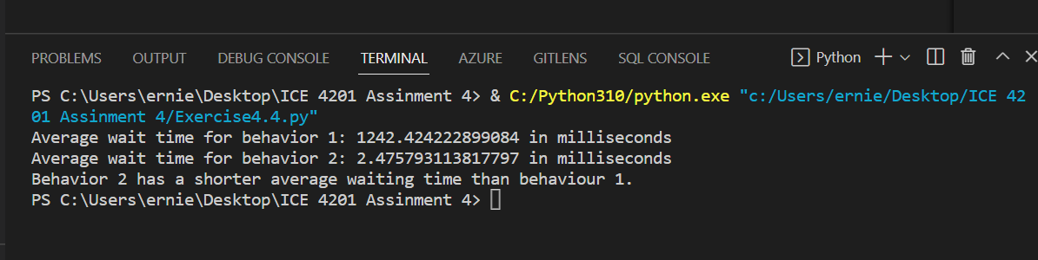

Discussion for Exercise 4.4
For the two-queueing behavior, the simulation algorithm for behavior 2 has a shorter average wait time than that for behavior 1. Therefore, the simulation for behavior 2 tends to be more time efficient.

Exercise 4.5 – Benchmarking Deques

import timeit
from timeit import Timer

class Deque:
def __init__(self):
self.items = []
def is_empty(self):
return self.items == []
def add_front(self, item):
self.items.append(item)
def add_rear(self, item):
self.items.insert(0,item)
def remove_front(self):
return self.items.pop()
def remove_rear(self):
return self.items.pop(0)
def size(self):
return len(self.items)

def testdeque():
# initialize deque
deque = Deque()

item = int()
#adds a new item to the front of the deque. It needs the item and returns nothing.
deque.add_front(item)

# adds a new item to the rear of the deque. It needs the item and returns nothing.
deque.add_rear(item)

# removes the front item from the deque. It needs no parameters and returns the item. The deque is modified.
deque.remove_front()

# removes the rear item from the deque. It needs no parameters and returns the item. The deque is modified.
deque.remove_rear()

# tests to see whether the deque is empty. It needs no parameters and returns a boolean value.
deque.is_empty()

# returns the number of items in the deque. It needs no parameters and returns an integer.
deque.size()

if __name__ == '__main__':
t = Timer("testdeque()", "from __main__ import testdeque")
print("testdeque for 1 million int",t.timeit(number=1000000), "milliseconds")

t = Timer("testdeque()", "from __main__ import testdeque")
print("testdeque for 10 million int",t.timeit(number=10000000), "milliseconds")

t = Timer("testdeque()", "from __main__ import testdeque")
print("testdeque for 100 million int",t.timeit(number=100000000), "milliseconds")
Random Number | TimeIt (Milliseconds)
1 million | 6.744944199999736
10 million | 54.824069499998586
100 million | 512.8630709999998

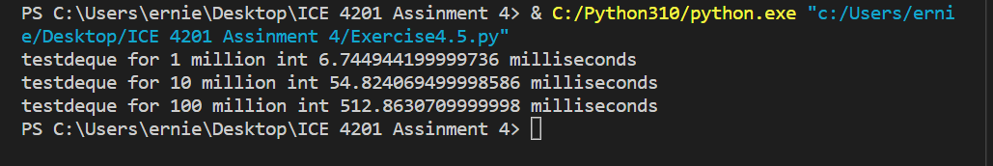

A deque is a linear data structure that allows elements to be added and removed from the front and the rear. This makes deques more flexible than both queues and stacks.
Deque is similar to queue in the sense that it operate as FIFO and like a stack items can as well be added at the end.
The advantage of deque to be able to add element like queues make it useful in certain situations where elements need to be added or removed from the middle of the deque. However, deques are generally less efficient than queues for adding and removing elements from one end, as they require more algorithm.
Therefore, deques are flexible linear data structures that allow elements to be added and removed from either end. They offer the benefits of both queues and stacks, but may not be as efficient as either for certain operations.

Exercise 4.6 – Using Deques
class Deque:
def __init__(self):
self.items = []
def is_empty(self):
return self.items == []
def add_front(self, item):
self.items.append(item)
def add_rear(self, item):
self.items.insert(0,item)
def remove_front(self):
return self.items.pop()
def remove_rear(self):
return self.items.pop(0)
def size(self):
return len(self.items)

def pal_checker(a_string):
char_deque = Deque()
for ch in a_string:
char_deque.add_rear(ch)
still_equal = True
while char_deque.size() > 1 and still_equal:
first = char_deque.remove_front()
last = char_deque.remove_rear()
if first != last:
still_equal = False
return still_equal

def find_palindromes(filename):
with open(filename, 'r') as f:
for line in f:
# Split the line into words
words = line.split()
for word in words:
# Check if the word is a palindrome
if len(word) >= 3:
print(word)

#print out the palindrone from the text
print(find_palindromes('palindrome.txt'))
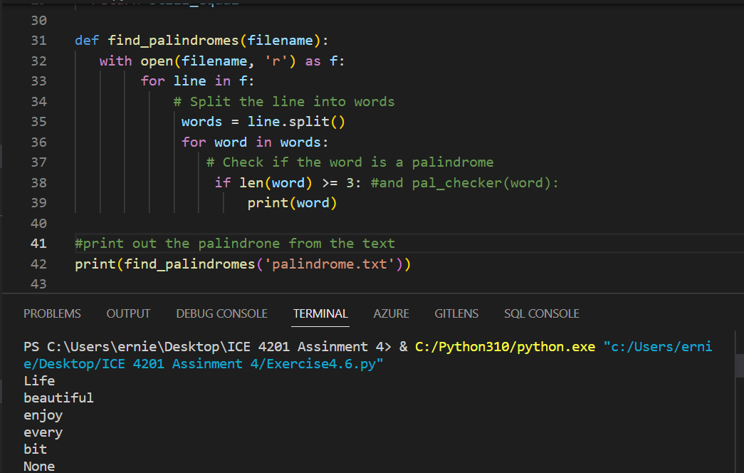
Analysis
The time complexity of the pal_checker function is O(n) due to the fact that the while loop's execution time is linear. The time complexity of the find_palindromes function is O(n * a) where n is the number of lines in the file and a is the average number of words in each line. This is because the for loop over the lines in the file has a time complexity of O(n), and the for loop over the words in each line has a time complexity of O(a). While the time complexity of the __init__, is_empty, add_front, add_rear, remove_front, remove_rear, and size methods are constant I.e O(n).

# For Benchmarking
deque = Deque()
import timeit
# measure the time taken to execute the add method
print('add front ', timeit.timeit(lambda: [deque.add_front(i) for i in range(10000)], number=1 ))

# measure the time taken to execute the add method
print('add rear', timeit.timeit(lambda: [deque.add_rear(i) for i in range(10000)], number=1 ))

#measure the time taken to execute the pop method
print('remove_front', timeit.timeit(lambda: [deque.remove_front() for i in range(10000)], number=1 ))

#measure the time taken to execute the remove method
print('remove_rear', timeit.timeit(lambda: [deque.remove_rear() for i in range(10000)], number=1 ))

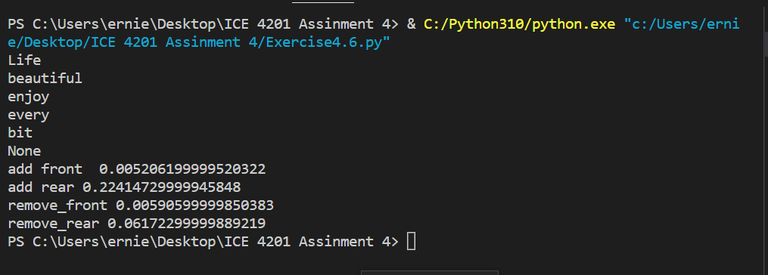

Exercise 4.7 – Implementing Unordered Linked Lists

class Node:
def __init__(self, init_data):
self.data = init_data
self.next = None
def get_data(self):
return self.data
def get_next(self):
return self.next
def set_data(self, new_data):
self.data = new_data
def set_next(self, new_next):
self.next = new_next

class UnorderedList:
def __init__(self):
self.head = None
def is_empty(self):
return self.head == None
def add(self, item):
temp = Node(item)
temp.set_next(self.head)
self.head = temp
def size(self):
current = self.head
count = 0
while current != None:
count = count + 1
current = current.get_next()
return count
def search(self,item):
current = self.head
found = False
while current != None and not found:
if current.get_data() == item:
found = True
else:
current = current.get_next()
return found

def append(self, item):
new_node = Node(item)
if self.head is None:
self.head = new_node
return
last_node = self.head
while last_node.next:
last_node = last_node.next
last_node.next = new_node
#function to insert an item to a position in the linkedlist
def insert(self, item, pos):
new_node = Node(item)
if pos == 0:
new_node.next = self.head
self.head = new_node
return
count = 0
cur_node = self.head
while cur_node:
count += 1
if count == pos:
prev_node.next = new_node
new_node.next = cur_node
break
prev_node = cur_node
cur_node = cur_node.next
#function to find the index of an item in the linkedlist
def index(self, item):
count = 0
cur_node = self.head
while cur_node:
if cur_node.data == item:
return count
cur_node = cur_node.next
count += 1
return None
#function to pop an item in the linkedlist
def pop(self, pos):
if pos == 0:
self.head = self.head.next
return
count = 0
cur_node = self.head
while cur_node:
count += 1
if count == pos:
prev_node.next = cur_node.next
return
prev_node = cur_node
cur_node = cur_node.next
return None
#function to find the index of an item in the linkedlist
def print_list(self):
cur_node = self.head
while cur_node:
print(cur_node.data)
cur_node = cur_node.next

list = UnorderedList()
print(list.is_empty())
list.add(10)
print(list.search(10))
print(list.is_empty())
list.append(45)
print(list.size())
list.insert(50, 0)
print(list.size())
list.pop(2)
print(list.print_list())
print(list.index(25))
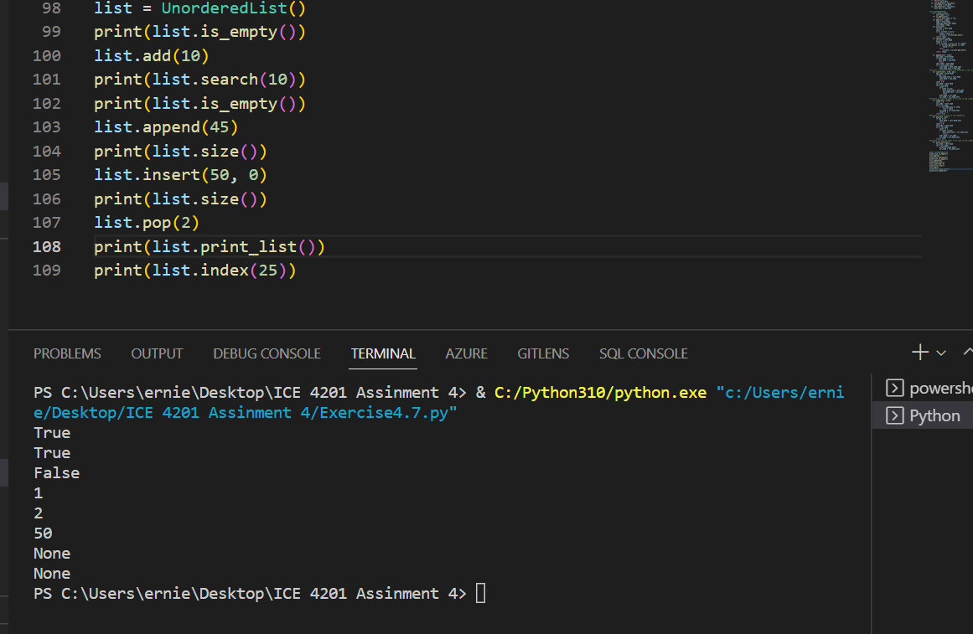
Analysis
The complexity of the append, insert, add, pop, search, index, and size are all linear algorithm. Thus, their complexity is O(n).

#For Benchmarking
import timeit

# measure the time taken to execute the append method
print('add for 1 million', timeit.timeit(lambda: [list.append(i) for i in range(1000000)], number=1 ))

# measure the time taken to execute the insert method
print('insert for 1 million', timeit.timeit(lambda: [list.insert(i, 100) for i in range(1000000)], number=1 ))

#measure the time taken to execute the pop method
print('pop for 1 million', timeit.timeit(lambda: [list.pop(i) for i in range(1000000)], number=1 ))

#measure the time taken to execute the index method
print('index for 1 million', timeit.timeit(lambda: [list.index(i) for i in range(1000000)], number=1 ))

